Anscome’s quartet

I was browsing the internet on this topic and found the following funny, but good example of anscome’s principle, called: The DataSaurus Dozen

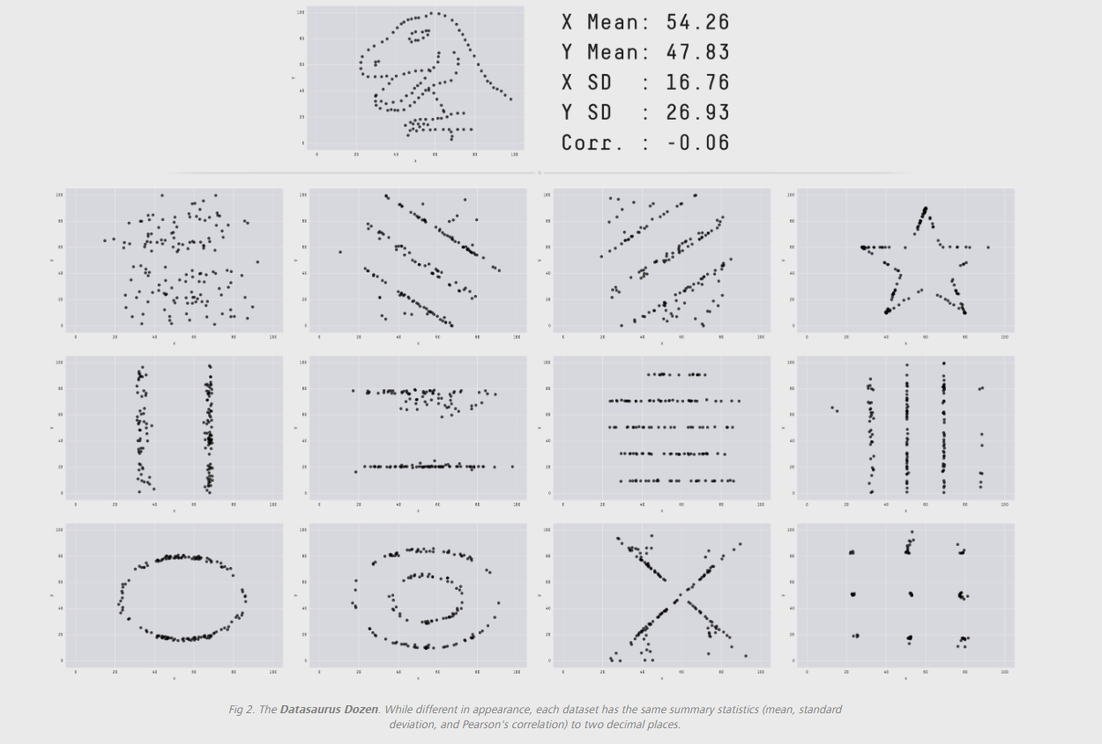

These are 13 different datasets that have been given the same mean, standard deviation, and Pearson's correlation, yet end up looking totally different when visualizing them.

The importance of the exploratory data analysis goes to show here. You can never trust the data until you see it with your own eyes. Always get yourself familiar with the dataset by just doing some exploring.